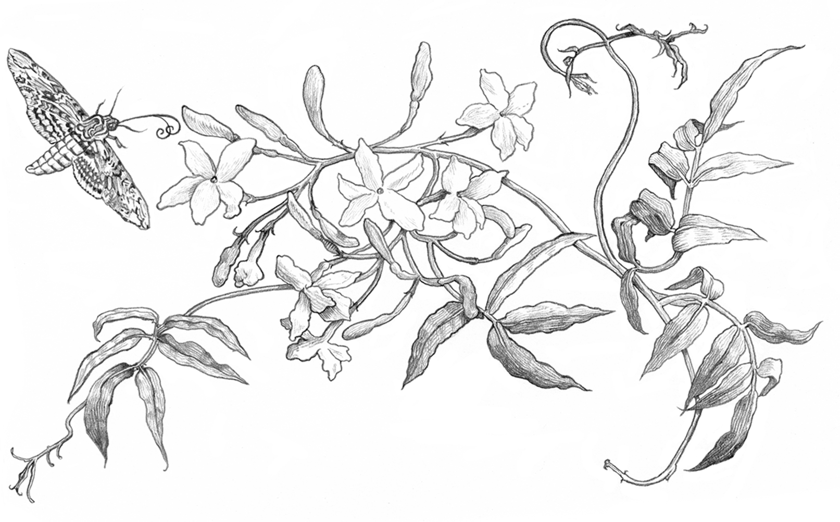

The first thing that hit me was the heat.
My dad always used to say there was nothing like a southern summer. He’d sit on the couch, sipping on a glass of lemonade so sweet just looking at it made my teeth ache, talking about days when the air got so thick you could taste it and the only thing that could chase it away was a good old-fashioned thunderstorm. But no matter how many times he’d warned me, nothing could have prepared me for the real thing.
I shuffled out of the backseat of the car and stepped onto the sidewalk, the heavy humidity pressing down on me, and peeled my already damp hair away from my forehead. Here I was at last: Savannah, Georgia, the town where my dad was born and raised. And now he was dead and buried in a completely different country, three thousand miles away.
‘Emily?’
A sweet, sing-song voice called my name from the other side of the car.
‘You OK?’
Ashley, the pretty young woman with a long brown braid

I’d met yesterday, examined me with a furrowed brow. I nodded my head even though I was not OK at all. How could I be?
‘Here we are, home sweet home,’ she said, hitching her purse up onto her shoulder as the driver took my single suitcase from the trunk. ‘What do you think?’
Staring up at the building behind her, I felt my mouth fall open. ‘This is home?’ I said, unable to process the concept. ‘You
live here?’
‘I do,’ she replied. ‘Don’t get excited, it’s just a house.’
But calling this place ‘just a house’ was like calling a Formula One Ferrari ‘just a car’. Sure, it had four wheels and an engine but it was not the same thing at all. The elegant white building in front of me was a work of art. It sat apart from its neigh- bours, as though too grand to be associated with such riffraff, and it was taller than the other buildings, the gentle grey roof reaching higher into the sky and lined with decorative but dangerous-looking spikes. As if a pigeon would dare to land on such grandeur. Each large sparkling window shone in the early evening light, all of them too high up from the street to offer anything other than the most tantalizing tease of what might be inside.
‘I think “house” is underselling it,’ I told her, pulling the straps of my backpack tight against my shoulders. ‘Are you sure this isn’t a hotel? Or a museum?’
She chuckled at that.
‘Definitely ain’t a hotel but it sure does feel like a museum sometimes. There’s a lot of history inside those four walls.’
An iron gate swung open on well-oiled hinges, welcoming me into a garden full of fragrant flowers and blossoming trees as I followed slowly up a set of stone steps to a pair of imposing double doors. Dark wood gleaming against the powdery white walls. Between my jetlag and the humid evening air, my vision was soft around the edges. I felt like I was in a dream.

‘Welcome to Bell House,’ Ashley declared, holding the front door open and ushering me inside. ‘Let’s go meet your grand- mother.’

If at all possible, the inside of the house was even more grand than the outside. I hovered by the door, one foot inside and one foot outside, as my tired eyes took in the glossy floors of the foyer, the imposing curved staircase and each immaculate piece of antique furniture. The walls glowed a soft sage green and when I looked more closely, I saw the silk wallcoverings had been painted with twisting vines that crept up and down, from floor to ceiling. Sleeping Beauty’s castle through an Instagram filter.
‘It’s amazing,’ I breathed as I stepped fully inside, hands still welded to my backpack, afraid to touch a thing. ‘But I can’t imagine anyone actually living here.’
Ashley replied with a half smile that didn’t quite reach her eyes. ‘And I can’t imagine living anyplace else.’
‘Why would you ever want to?’ asked another voice. ‘When we have our own little slice of heaven right here.’

One day earlier, when I opened the front door of our cottage in Wales, and laid eyes on Ashley for the first time, I knew right away that we were related. The dimple my dad hid underneath his beard was on display in her left cheek, her mouth quirked up at one side before she committed to a full grin the same way he did, and most noticeable of all, she and I shared the exact same shade of emerald green eyes. We didn’t need all the paperwork she presented to Anwen, the family friend I’d been staying with since Dad’s accident. What were stamps and seals and protocols when the family resemblance was as clear as day? And it wasn’t just the physical likeness. While Ashley sat in our living room, explaining how she was my aunt, my dad’s

estranged younger sister I knew nothing about, and that I had a still-living grandmother waiting for me across the ocean, there was a pull in my bones I couldn’t explain. Something in me whispered that she was telling the truth. It was the kind of confirmation you could never get from a piece of paper.
And now, as a tall, elegant older woman descended the staircase, the same promise pulsed through my veins. She was my blood, or I was hers. We were the same. Only this time instead of the altered reflection of my dad I’d seen in Ashley, I saw myself smiling back at me. Our hair was different, hers was red where mine was brown, but aside from that, it was as though someone had taken all my awkward facial features – my wide-set eyes and too broad mouth – and reassembled them beautifully, balancing it all out with elegance and grace. Looking at her was like staring into the world’s kindest funhouse mirror. Could this really be my grandmother?
‘I’m Emily,’ I said, fumbling for the right words and finding only the facts. ‘Paul’s daughter.’
Her arms were around me before I could finish my sentence and unbidden tears filled my eyes at once. She smelled like flowers and herbs and the summer sun, and underneath all that, there was something warm, more familiar. She smelled like my dad.
Eventually she released me, cupping my face in her hands, and I could see she was crying too.
‘Any fool could see it,’ she whispered, her own emerald-green eyes rimmed red. ‘Oh my goodness, my granddaughter. I can’t tell you how happy I am to have you home.’
Ashley yawned loudly, breaking the silence as I stared back, mesmerized by this beautiful woman and already missing the warmth of her hug. Dad wasn’t much of a hugger, more a solid pat on the shoulder kind of a guy. I had never felt so confused in my life.

‘Catherine James Bell, may I present Miss Emily Caroline James,’ my aunt said in a ceremonious voice. ‘Miss Emily Caroline James, this is Catherine James Bell. My mother and your grandmother.’
‘You look too young to be a grandmother,’ I blurted out quickly, too tired to mind my manners.
Her skin was porcelain pale and translucent, without a single visible blemish or line, and she wore her long red hair pulled back in a soft French pleat with not one grey strand in sight. There was no way she was old enough to have a sixteen-year-old granddaughter.
Catherine laughed loudly as she wrapped her arm around my shoulders, shepherding me into the parlour.
‘Oh, I like you already,’ she said, leaning her head against mine. ‘Ashley, darling, how was the flight?’
‘Awful, thanks for asking.’
My aunt peeled off her cardigan and cast it over the high back of a blue and white chair before rolling up her shirtsleeves. ‘How do we feel about tea?’
‘Sounds divine, and perhaps a little snack?’ Catherine looked down at me kindly, one questioning eyebrow raised. ‘Unless you’d like something more substantial? I myself cannot stand to eat a heavy meal when the weather is so ugly but you’re still a growing girl. We can’t have you going hungry.’
‘A snack sounds good,’ I mumbled, still struggling to find my voice. ‘Thank you again . . . Grandmother?’
The word lingered on the tip of my tongue as I tried it on.
Nope, didn’t quite fit yet.
‘Why don’t you call me Catherine for now,’ she suggested as Ashley disappeared, leaving the two of us alone in the parlour. ‘And no more thank yous, that’s an order. There’s no need to thank family for being family.’
I bit my dry, chapped lower lip as she guided me to sit on

a powder blue loveseat before dropping neatly onto the couch opposite. Catherine was so perfectly put together, I couldn’t help but feel like a schlub in my plane-rumpled travel outfit but if she was judging me as harshly as I was judging myself, it didn’t show. All I saw on her face was joy, her eyes lit up with delight and staring at me like I was the eighth wonder of the world.
‘We’ll do a tour of the house when you’ve had a chance to rest.’ She leaned forward and beamed at my hot, pink face. ‘Oh, Emily, you really are your father’s daughter, aren’t you? And I would recognize those eyes anywhere.’
‘The same as yours,’ I replied. ‘And Ashley’s.’
Catherine nodded and leaned back against the couch while I shifted around in my seat. Exhausted as I was, I couldn’t seem to sit still.
‘Scientists might call it a dominant gene,’ she said with a wink. ‘But as my grandmother would have said, there’s simply no denying a Bell.’
Only I wasn’t a Bell. Or at least I hadn’t known I was until Ashley showed up twenty-four hours earlier. Yesterday, I was Emily Caroline James, sixteen-year-old daughter of Paul and Angelica James, the father who died when his car smashed into a tree during a springtime storm two months ago, and the mother I lost when I was just a baby. Yesterday, I was at home in Wales, an orphan. Now I was in Savannah, gazing into the face of a dead woman.

